**MMED Project Report 2017**

Screening algorithms and HIV risk to blood transfusion recipients in South Africa

**Group Members**

Jeremy Bingham, Lamin Juwara, Sara Levintow, John Macharaga, Laurette Mhlanga

**Faculty Mentors**

Eduard Grebe, Cari van Schalkwyk

**Introduction**

Screening blood donations for viral infections is a critical strategy to reduce risk of transmission through transfusion. Prior to routine screening, viral infections such as human immunodeficiency virus (HIV) were transmitted through infectious blood transfusions. In response, blood banks have employed effective screening strategies to minimize the risk that infectious agents will be transmitted through blood transfusion. However, most screening algorithms for infectious agents have imperfect sensitivity; not every true case of infection will be successfully detected. For HIV, screening tests fail to detect the virus for a short period after an individual is infected. This imperfect sensitivity results in a window period: the delay between the time an individual is infected and the time when the screening test is able to detect the infection. Blood banks aim to decrease the duration of the window period, thereby missing fewer cases, but this increased sensitivity comes at a high cost.

In South Africa, there are currently two organizations that offer blood transfusion services: the South African National Blood Service (SANBS) and the Western Province Blood Transfusion Service (WPBTS), which supplies the Western Cape Province only. First, the blood donor’s eligibility is determined through a self-evaluation form. If the blood donor reports risk factors (injecting drugs and having sex with someone they do not know), they are deemed ineligible for blood donation. To be eligible, the potential donor must be between 16 to 65 years and over 50kgs, with an acceptable hemoglobin concentration.

Once the blood has been harvested from the donors, it is screened for HIV, Syphilis and Hepatitis. The current screening strategies in South Africa are the antibody/antigen test and nucleic acid test (NAT). In the case of HIV, once the blood samples are received, they are tested for the presence of HIV P24 antigen/antibodies using the serological assay. Unfortunately, the antibody/antigen test is unable to detect HIV until an average of 10.8 days after infection. This is the test that South African blood banks use first as it is much less expensive than NAT. All blood units that test positive by the antibody/antigen test are discarded, and the donors are eliminated from the donor pool. For the blood samples tested negative, NAT is used, which detects the pathogen itself and is able to detect HIV on an average of 4.22 days after infection. NAT reduces the residual risk of transmission by shortening window period from 10.8 to 4.22 days, but results in an additional cost of $7 per test.

The current screening algorithm in South Africa is to perform individual NAT for each HIV antibody/antigen-negative sample. The individual NAT testing comes with a very steep cost for the blood transfusion services. Their main interest is to incur as few costs as possible in testing and screening of donated blood, but also providing the safest blood to the nation. This raises a question of whether it is effective to pool blood samples for NAT screening, at the expense of an increased window period. Pooling is a technique that allows several blood samples (units) to be tested at the same time in one test-tube. If the pool is tested positive, the samples are retested individually to determine the unsafe blood unit(s) in the pool. The advantage is that the cost associated with the testing is reduced, but pooling reduces the sensitivity of the test and the duration of the window period is increased. Using viral load growth rate during acute infection presented in Fiebig et al. (2003), pooling will increase the window period from 4.22 to 5.08 days for a pool of 2 samples, 6.22 days for a pool of 5 samples, and 7.08 days for a pool of 10 samples.

This report presents a study based on a simulation platform that mimic the dynamics of blood donation and screening mechanism in South Africa, starting from when the blood is collected. The study aims to determine the average number of HIV-positive blood samples missed by antibody/antigen testing that are detected by NAT, and how pooling blood samples (antibody/antigen test-negative) for further NAT screening affect the screening cost and the window period.

Our main project objectives are stated below:

1. How many HIV-positive donations are detected with individual NAT testing that would go undetected with ARCHITECT?
2. What is the effect of pooling samples for NAT on costs and undetected HIV-positive donations?

**Methods**

We conducted a simulation study to address our research questions using data from the 2015 SANBS national report and parameters from a mathematical model of the South African HIV epidemic, known as THEMBISA. We simulated the dynamics of blood donation screening in order to: 1) estimate how many HIV-positive donations are detected by NAT, that would be missed by the antibody/antigen test (donations occurring during the serological assay window period, but after the NAT window period), and 2) to estimate how many HIV-positive donations are missed by NAT (donations occurring during both NAT and antibody/antigen window periods). Simulating HIV-positive blood donations enabled us to estimate the benefit of NAT, in terms of number of HIV infections averted, as well as the associated costs, given that NAT is a more expensive screening test.

For our simulation approach, we created a model population of blood donors in South Africa for the year 2015. We then examined the number of HIV-positive individuals who would be detected at either stage of a combined individual antibody/antigen assay and individual NAT assay, which is the current screening strategy (Figure 1). Since 2005, the SANBS policy is to perform an individual NAT test for every blood sample with an antibody/antigen-negative result. For HIV-uninfected donors, the NAT result will also be negative. For HIV-infected donors, the NAT result will be positive as long as the test is not performed within the NAT window period (average of 4.22 days after infection).

**Figure 1.** SANBS blood screening algorithm.

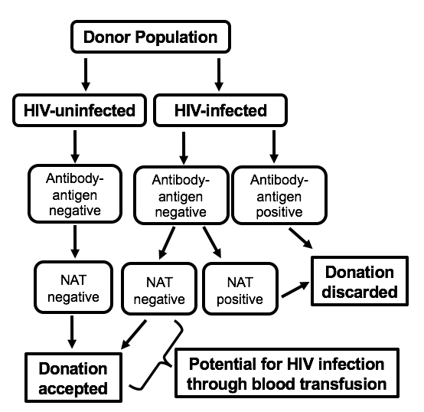

We compared the current strategy of individual NAT testing to potential scenarios in which blood donations are pooled. Pooling multiple antibody-negative blood samples could lower costs, but would also increase the viral load threshold for which the test will detect an HIV-infected sample within the pool. Thus, pooling multiple samples lengthens the window period, increasing the delay between the time an individual is infected and the time when NAT detects the infection. We estimated the reduced costs of pooling 2, 5, or 10 samples for NAT testing and the increased number of HIV-positive donations that NAT would fail to detect in pooled samples. This simulation could inform a potential change in policy for South African blood banks through estimating the costs and benefits associated with pooling.

To carry out the simulation, we selected parameters based on data from the 2015 SANBS national report and the THEMBISA model of the South African HIV epidemic. The key data points obtained from the SANBS annual report were the total numbers of blood donors and donations in 2015 (490,914 donors and 814,492 donations), dynamics of donation (88% of donors have donated previously), the HIV prevalence detected by SANBS among blood donors (0.0023). In our simulation, the HIV status of each donor at the start of the year was randomly generated from the binomial distribution, using this probability of 0.0023. Blood donation times through 2015 randomly generated from uniform distribution. The key parameter obtained from the THEMBISA model was the HIV incidence (0.006 cases/1 person-year). In our simulation, HIV infection during the year was randomly generated from the binomial distribution, using this probability of 0.006. HIV infection times throughout 2015 randomly generated from uniform distribution. Our other key assumptions were that prevalent and incident HIV-positive donors donate only once, and that HIV-negative people donate only once or twice. The cost of an individual NAT test was assumed to be $7, and we calculated the overall cost of NAT screening by multiplying $7 by the total number of donations. We divided this overall cost by the number of HIV-infected donations detected by NAT, that would be missed by the antibody/antigen test, to estimate the cost per HIV infection detected with NAT. These HIV-infected donations detected only by NAT would have occurred during the antibody/antigen window period, but after the NAT window period.

All simulation analyses were conducted using R Version 3.3.1 (R Foundation for Statistical Computing, Vienna, Austria). Our code repository is available at the following link: <https://github.com/ICI3D/screeningAlgorithms/tree/master/code>

**Results**

Given our simulation parameters and assumptions, we constructed a model population of 490,914 donors with a stochastic distribution of key characteristics, such as HIV status during 2015 and the timing of blood donation. Table 1 summarizes these characteristics of our model population, based on repeating the simulation 100 times.

|  |  |  |
| --- | --- | --- |
| **Table 1.** Model population (n=490,914). | Median simulated value | Observed data or model parameter |
| Total number of donations | 815,686 | 814,492 |
| Prevalent HIV-positive donors at start | 1,124 | HIV prevalence = 0.0023 |
| Incident HIV-positive donors during year | 2,940 | HIV incidence = 0.006 |
| Overall cost of NAT testing | $5,709,798 | $7/test |

We simulated the dynamics of blood donation and HIV incidence throughout 2015 and calculated the numbers of HIV-positive donations that occurred during the antibody/antigen window period (first 10.8 days from infection) and during the NAT window period (first 4.22 days from infection). HIV-infected donations occurring during the window period would go undetected by the test. Results from our simulation, repeated 100 times, are reported in Table 2.

|  |  |
| --- | --- |
| **Table 2.** Simulation results (100 replicates). | Median simulated  value |
| Number of HIV-positive donations undetected by antibody/antigen test | 88 |
| Number of HIV-positive donations undetected by NAT  (undetected by antibody/antigen test) | 33 |
| Number of HIV-positive donations detected by NAT  (undetected by antibody/antigen test) | 55 |
| Total cost of NAT for all donations  ($7 per individual NAT test) | $5,709,798 |
| Cost per HIV-positive donation detected by NAT, that was missed by antibody/antigen test | $103,815 |

Next, we varied the hypothesized HIV incidence among blood donors, given that the true incidence in this population is likely lower than the incidence observed in the general South African population (0.006). We ran the simulation for incidence values ranging from 0.001 to a maximum of 0.006, replicating the simulation 100 times at each incidence value. We then examined the number of HIV cases that would go undetected in each model population by screening test and explored how the numbers of missed cases changed due to varying HIV incidence. Figure 2 shows the number of HIV-infected donations missed by each screening test over the range of hypothesized incidence values. When HIV incidence is assumed to be very low, few HIV infections are missed with either screening test. With high HIV incidence, there is a more substantial difference in number of missed cases when comparing NAT with the antibody/antigen test. At higher incidence, NAT detects a greater number of HIV infections that would have been missed by using the antibody/antigen test alone.

**Figure 2.** Median HIV-infected blood donations undetected by antibody/antigen testing and nucleic acid testing, by hypothesized HIV incidence among blood donors (n=100 replicates at each incidence value).

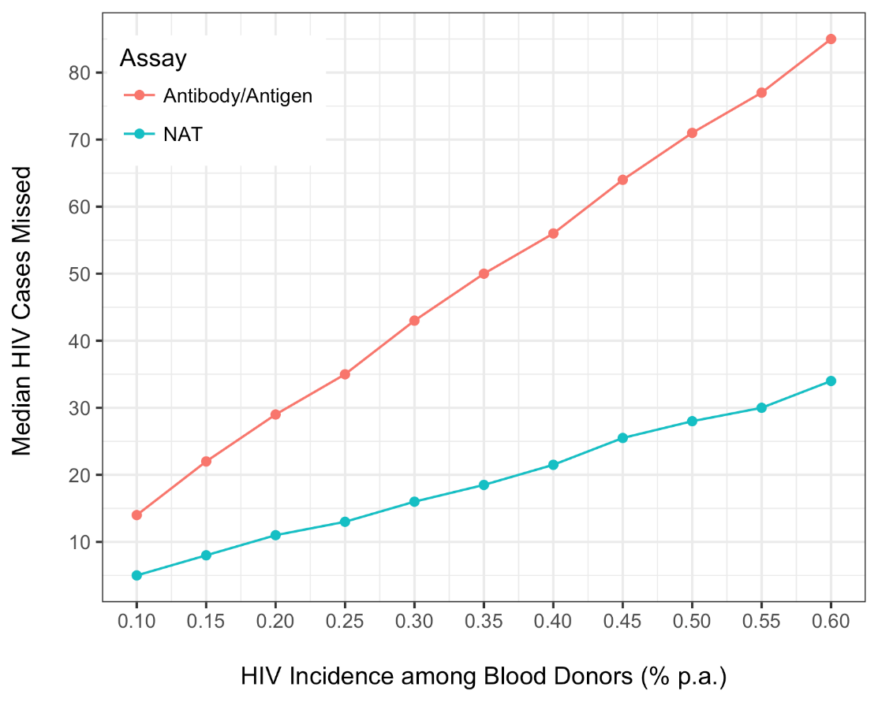

We also explored changes in cost per HIV-infected donation detected by NAT, that would be missed by the antibody/antigen test. Figure 2 shows how this cost changes, based on varying HIV incidence. As HIV incidence increases, there is a reduced cost per HIV infection detected with NAT (that would go undetected by the antibody/antigen test). This reduced cost results from a higher number of HIV-infected donations detected by NAT, that would be missed by the antibody/antigen test. Thus, the overall cost of NAT testing is paying for a greater number of HIV-infected donations to be detected, that would otherwise be missed.

**Figure 3.** Median cost per HIV-infected donation detected by NAT (missed by antibody/antigen test), by hypothesized HIV incidence among blood donors (n=100 replicates at each incidence value).

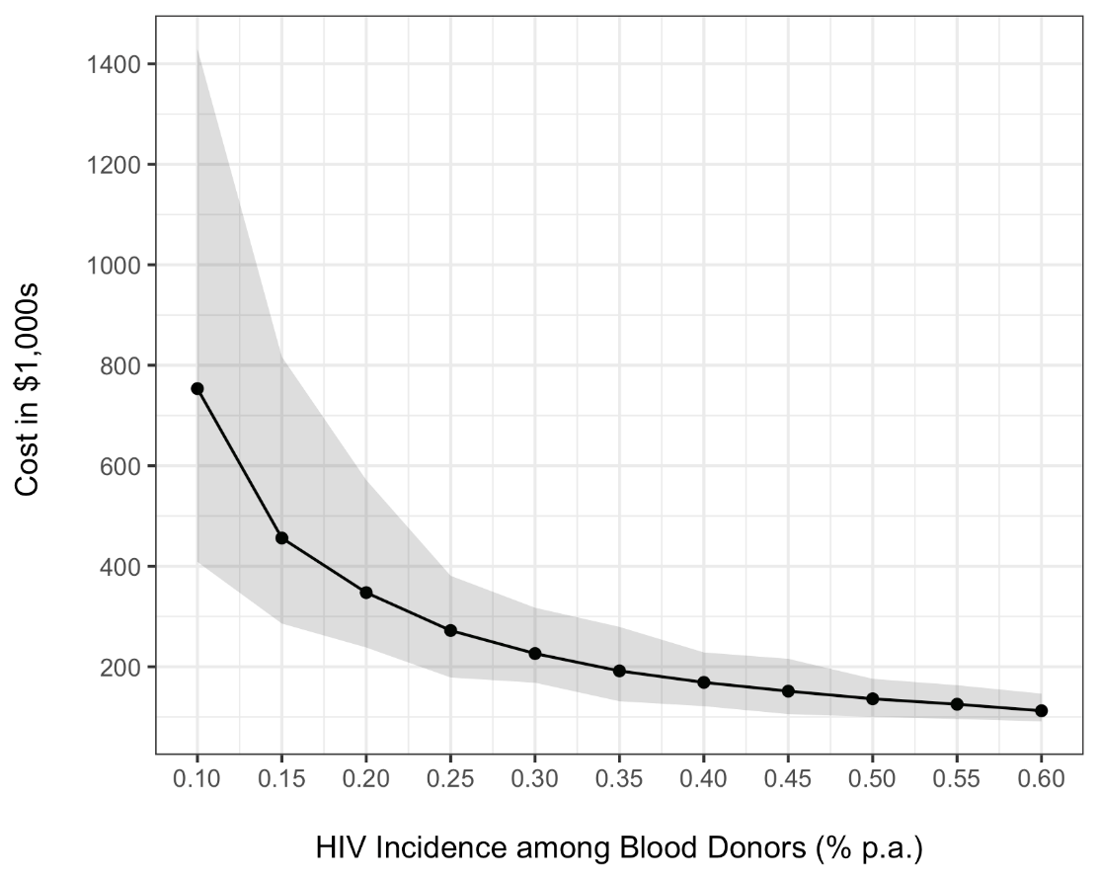

Table 3 reports the results from comparing individual NAT testing to different pooling scenarios. Individual NAT testing is the current policy and is able to detect the highest number of HIV-infected donations that would be missed by antibody/antigen testing alone. This number of HIV-infected donations detected through NAT screening decreases as the pool size grows, given that pooling reduces the sensitivity of NAT and lengthens the window period. However, individual testing is the most expensive. The total cost of NAT screening could be substantially reduced from $5,714,709 to $573,641 with the largest pool size, at the expense of missing 24 HIV-positive blood donations.

Table 3. Pooling analysis results.

|  |  |  |
| --- | --- | --- |
| Screening strategy | Number of HIV+ donations missed by antibody/antigen and detected by NAT | Total cost of NAT screening |
| 1 NAT test/1 sample | 55 | $5,714,709 |
| 1 NAT test/pool of 2 | 49 | $2,858,040 |
| 1 NAT test/pool of 5 | 37 | $1,144,517 |
| 1 NAT test/pool of 10 | 31 | $573,641 |

In summary, our simulation indicates that despite its high cost, NAT screening is able to detect some of the HIV-infected donations that are missed by antibody/antigen testing. The cost per HIV infection detected with NAT is lowest if HIV incidence among blood donors is assumed to be similar to the South African general population. However, if the donor population has a lower HIV incidence, the number of HIV-infected donations detected only with NAT decreases, making the cost of NAT much higher in comparison. Thus, if HIV incidence is lower among donors than in the general population, pooling strategies are a more cost-efficient approach than the current individual testing strategy. Potential savings could be redirected to other key HIV prevention efforts in South Africa, such as pre-exposure prophylaxis, condom use and distribution, voluntary medical male circumcision, and elimination of mother-to-child transmission.

**Issues**

The major issue we have encountered is the need to make simplifying assumptions for the simulation. We have had to balance the complex realities of the dynamics of blood donation and HIV infection with our R coding abilities and simulation skill set. Relaxing some of the assumptions in our simulation would enable us to draw more meaningful conclusions from the study. Below, we have listed the simplifying assumptions made in our analysis to date and the rationale for each:

* Assumption that the antibody/antigen and NAT window periods are equal to exactly 10.8 and 4.22 days, respectively: on average, these are the duration of the window periods, but in reality there is individual variability.
* Similarly, the assumption that the NAT window period increases to exactly 5.08, 6.22, and 7.08 days for pools of 2, 5, and 10 samples: these are reasonable estimates based on the viral load growth rate during acute infection (Fiebig et al, 2003), but uncertainty in these estimates should be incorporated.
* Assumption that HIV prevalence in the donor population is equal to the SANBS estimate: observed prevalence in SANBS is an underestimate due to missed cases occurring during the NAT window period, but as indicated by our study, very low numbers of HIV-infected donations are missed.
* Assumption that HIV incidence in the donor population is equal to THEMBISA’s parameter for South African general population incidence: we also explored lower incidence values, given that the donor population is likely healthier than the general population.
* Assumption that HIV-negative donors donate only once or twice during the year: only a minority of donors donate more than twice in a year, and simulating only one or two donations per donor greatly simplified our coding.
* Assumption that the overall cost of NAT can be calculated with the total number of donations: antibody/antigen-positive donations would not be further tested with NAT and should be excluded from the cost calculation. However, this is a very small number relative to the antibody/antigen-negative donations that are tested with NAT.

**Plans**

We are willing to proceed with this project and push it for publication but we need to re-evaluate our approach. The assumptions that were initially made need to be adjusted so that the blood donation algorithm is more realistic and not the simple assumptions presented in the report. Some of the interesting features we would like to look at in-depth are outlined below.

In this report some simple assumptions were made e.g. we assumed that people are only allowed to donate once or twice and for simulation purposes these individuals are drawn from a binomial distribution. A more realistic approach will be to allow a maximum of 5 donations per year, with a minimum of 60 days in-between donations. This results in the repeat donors being drawn from a Poisson distribution. Of course, this will require assuming that infections only happen in the period leading to the last donation (e.g. for a repeat donor who donates 5 times, infection can only happen between the 4th and 5th donations if turns out to be an incident case).

Another possible pathway that may be interesting to look at is the multi staged pooling suggested by Quinn et al. (2000) or pooling pools as described in Williams (2010). This is when a pool is tested positive, instead of testing them individually, smaller pools are created and retested. For example say, we start with a pool of 16 samples, given the pool tests positive, smaller pools of 4 samples are then made and tested again (Williams, 2010). This is an attractive approach and can be very cost effective as compared to the single pools approach.

Williams derived the optimal pool size formulae (see Williams 2010), it will be worth pursuing (taking our HIV prevalence into consideration) how our simulated dataset performs using the formulae. We can ask questions such as: What is the optimal pool size associated with it, and the amount of money saved by the implementation of the optimal pool size formulae for this strategy? If the initial pool size is large enough will the multi staged pooling further decrease the cost associated with testing of blood?

Other key aspects of our study that we plan to continue working on are to allow for more stochasticity in our simulation results and to perform an in-depth cost analysis. We plan to relax some of our simplifying assumptions and allow for greater uncertainty in our simulation parameters. The pooling analysis is currently based on a single simulation run; we plan to examine the effects of stochasticity by repeating each pooling simulation 100 times. For the cost analysis, it is important to consider the costs of NAT alongside the costs of lifetime HIV care and the ethical considerations of potential HIV infection through blood transfusion.

Our timeline is still being determined, but we are interested in continuing these analyses throughout the rest of 2017 and aim for manuscript submission in 2018.

**Contributions**

All group members contributed to the development of our project’s research questions and analytic approach. During MMED, Laurette and John reviewed background information and developed the presentation slides on the introduction, study rationale, and research questions; Lamin and Jeremy developed the presentation slides on the methodology, conclusions, and next steps and provided input on R coding; Sara developed the presentation slides on the project’s results and also provided input on R coding.

**References**

1. South African National Blood Service. (2016). 2016 Integrated Annual Report.
2. Johnson LF, Chiu C, Myer L, Davies MA, Dorrington RE, Bekker LG, Boulle A, Meyer-Rath G. (2016). Prospects for HIV control in South Africa: a model-based analysis. Global Health Action.
3. Bruhn R, et al. (2013). Prevalence of human immunodeficiency virus RNA and antibody in first-time, lapsed, and repeat blood donations across five international regions and relative efficacy of alternative screening scenarios.
4. Cable R, et al. (2013). Reduction of the risk of transfusion-transmitted viral infection by nucleic acid amplification testing in the Western Cape of South Africa: a 5-year review.
5. Chavez P, et al. (2011). Evaluation of the performance of the Abbott ARCHITECT HIV Ag/Ab Combo Assay.
6. Delaney, KP, et al. (2016). Time until emergence of HIV test reactivity following infection with HIV-1: implications for interpreting test results and retesting after exposure.
7. Dodd RY, et al. (2016). Development of a multisystem surveillance database for transfusion-transmitted infections among blood donors in the United States.
8. Fiebig EW, et al. (2003). Dynamics of HIV viremia and antibody seroconversion in plasma donors: implications for diagnosis and staging of primary HIV infection.
9. Johnson LF, et al. (2016). Prospects for HIV control in South Africa: a model-based analysis.
10. Vermeulen M, et al. (2013). Comparison of human immunodeficiency virus assays in window phase and elite controller samples: viral load distribution and implications for transmission risk.
11. Zou S, et al. (2012). Donor testing and risk: current prevalence, incidence, and residual risk of transfusion-transmissible agents in US allogeneic donations.
12. Quinn, TC, et al. (2000). Feasibility of pooling sera for HIV-1 viral RNA to diagnose acute primary HIV-1 infection and estimate HIV incidence.
13. Williams, BG. (2010). Optimal pooling strategies for laboratory testing.